Girl Scouts of Connecticut
2023-2024 Troop Cookie Volunteer
eBudde Instructions
Choosing a Troop Proceeds Option

Daisy and Brownie troops must take the girl reward option, which is the default in eBudde.
Junior level and older troops can choose to take additional proceeds instead of individual girl rewards.
All troops should check to ensure the correct proceed option is selected.
Go to the Settings tab to see the proceeds option that is set for your troop.
To change to proceeds option for your troop from the troop dashboard, select Settings
Select Edit
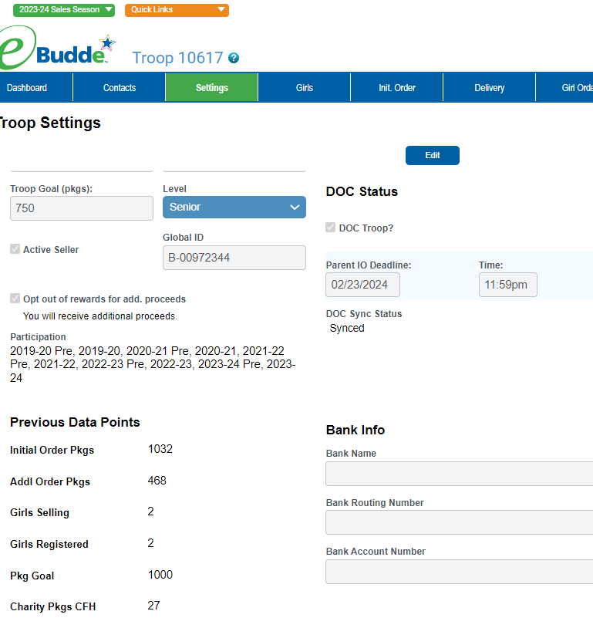

If the Opt out of rewards for add. proceeds box is not checked then your troop is set to receive the girl rewards.
To opt out of rewards and receive the additional $0.10 in troop proceeds Check the box Opt out of rewards for add. proceeds. It should now say You will receive additional proceeds. Scroll to the bottom of the page and click Update to save. You must click the Update button, or the selection will not be saved.

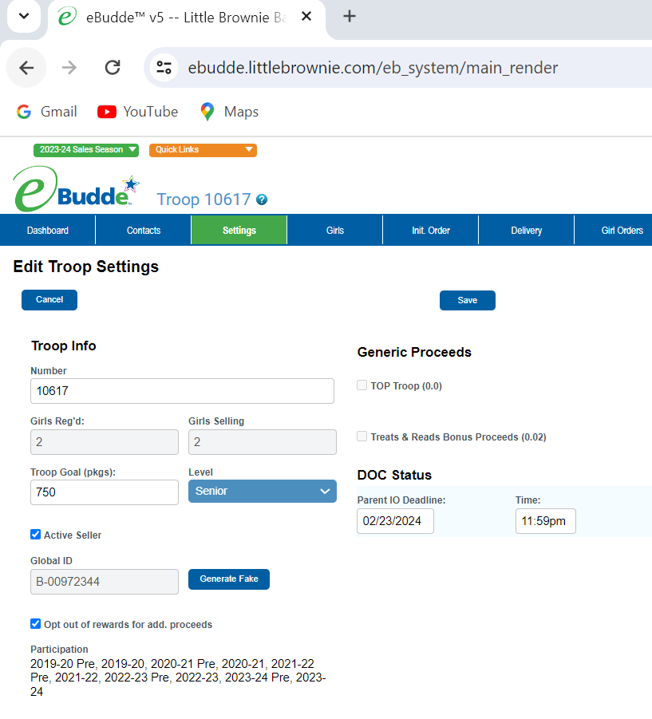

Remember that only Junior and older troops may select to receive the additional proceeds instead of individual girl rewards.
The troop members should vote on whether or not to take the additional proceeds.

