Girl Scouts of Connecticut
2023-2024 Troop Cookie Volunteer eBudde Instructions
Understanding the Girl Order Tab in eBudde

The Girl Orders tab is where the majority of steps need to be taken during the goal getters/booth sales portion of the program. The Girl Orders tab is where the troop can:
• Allocate Goal Getter packages, booth sale packages AND Cookies for Heroes (CFH) packages to individual girls.
• View the total number of packages, including packages sold on the Initial Order AND online via Digital Cookie that each girl has sold.
• View the total amount due from each girl/family. There are two views within the Girl Orders tab – the Troop Summary view and the Girl Detail view. The system defaults to the Troop Summary view. The Girl Detail view can be accessed by double clicking a girl name from the Troop Summary View.
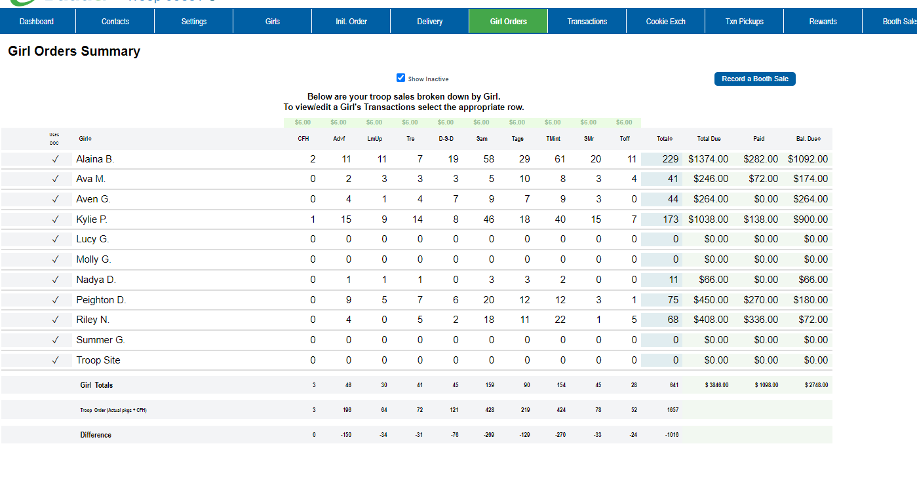
Troops can view total sales for each Girl Scout from the Troop Summary view. Cookie orders are listed in columns by variety.
CFH- These cookies were sold by girls in support of the council’s Cookies for Heroes Program. These are ‘virtual’ packages that the troop does not handle; they are distributed by council. Only donated packages for the Cookies for Heroes Program are recorded under this column, not those sold for a local gift of caring. The CFH column includes Cookies for Heroes packages that were sold as part of the Initial Order AND is also where any Cookies for Heroes packages sold during Goal Getters/booth sales are recorded. Any CFH packages sold via Digital Cookie are automatically added to this column.
The number of packages in the columns for each variety and the total includes:
- All orders entered on a girl’s Initial Order paper order card,
- Those Digital Cookie orders for girl delivery during the Initial Order Taking Period (excluding Cookies for Heroes packages),
- Digital Cookie direct shipped orders during the Initial Order or post-Initial Order Taking Period, AND
- any cookies allocated to a girl for goal getters and booth sale cookies (other than Cookies for Heroes packages – they are found under the CFH heading) and those packages ordered for girl delivery through Digital Cookie after the Initial Order was submitted.
The following are the types of Digital Cookie orders that will be recorded automatically on eBudde and credited both to the troop and the Girl Scout who sold them. No further action is needed by the troop:
- Sold through Digital Cookie for direct ship (during both the Initial Order Taking Period and post-Initial Order);
- Sold through Digital Cookie for donation (during both Initial Order Taking Period and post-Initial Order); and
- Sold through Digital Cookie for girl delivery during the Initial Order Taking Period.
Cookies sold through Digital Cookie for girl delivery during the post-Initial Order Taking Period do not automatically record on the Girl Orders tab; however, the money paid by the customer is credited to both the Girl Scout and the troop. Cookies sold for girl delivery during the post-Initial Order period need to be obtained at a cupboard or from the troop’s inventory and need to be allocated to the Girl Scouts who sold them.
Total– The total number of packages sold by the girl through the Initial Order, Goal Getter sales, booth sales, and Digital Cookie.
Total Due– This amount is calculated by taking the total cookie packages sold and multiplying by $6.00. NOTE: Only girl/family payments to the troop are calculated on this tab. Troop proceeds and amounts due to council can be viewed on the Sales Report tab.
Paid– This column will display all payments made by the Girl Scout to the troop AND payments that were made via credit card for cookies ordered through Digital Cookie. Troop cookie managers must enter payments for any in-person orders that are accepted by parents and given to the troop volunteer for this calculation to be correct. Any credit card payments received through Digital Cookie are included in the calculation of the amount due and do not need to be added manually by the troop cookie manager.
Bal Due– This is the balance that is due from the girl/family. NOTE: For this calculation to be correct, all packages needed to fill girl orders MUST be added to her record, including packages needed for Digital Cookie girl delivery orders that were placed AFTER the Initial Order Taking Period. If a Girl Scout has orders for girl delivery that were placed after the Initial Order was submitted and the cookies have not yet been allocated to the Girl Scout by the troop, the balance due will be lower than the amount she actually owes. This is because the online payments for girl delivery orders were credited to the Girl Scout, but the packages are NOT automatically recorded for orders received AFTER the Initial Order Taking Period. Once the packages needed for the additional girl delivery orders have been added, the balance due will match up with the number of packages sold and payments received.
Troop volunteers can see if there are any girl delivery orders that have not been added to the Initial Order by going to the Reports tab and running the report titled “Girl Delivery – Varieties only – By Girl”. You will select the Order Detail tab and then look under the “IO Added” column. If the value in that column is “no”, then the order was not added to the Initial Order and the cookies will have to be manually allocated to the Girl Scout’s record on the Girl Orders tab. The Girl Scout’s caregiver will also have that information on her/his Girl Scout’s Digital Cookie site.

The Girl Order tab at the end of the Cookie Program
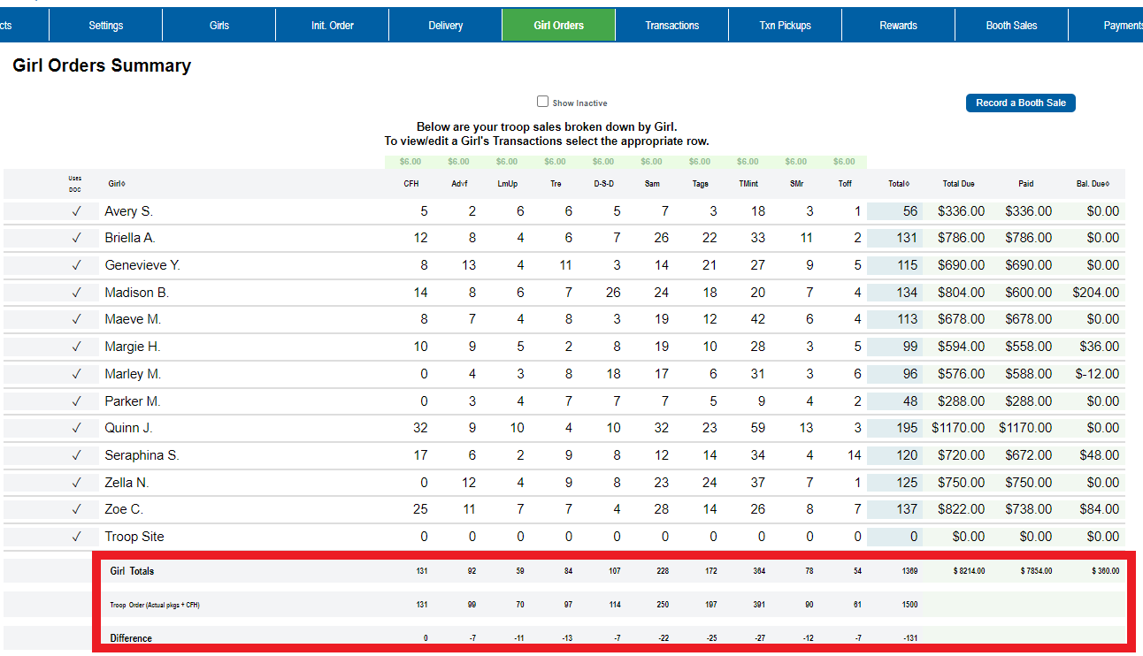
Girl totals—These are the total packages sold by each girl. All packages sold, regardless of if they were sold online, in-person, at a booth sale, as Goal Getters, during the Initial Order Taking Period, or for Cookies for Heroes, are included in this total. This is the total that will be used to calculate girl rewards. At the end of the Cookie Program, the Girl Totals and the Troop Order should be the same. When this is the case, all packages received by the troop have been allocated to girls.
Troop Order—These are the total packages assigned to the troop and include ALL packages the troop is financially responsible for, including all packages ordered for girl Initial Orders, surplus packages from the troop’s Initial Order, Cookies for Heroes packages, packages transferred from another troop, packages picked up (but not returned) from a cookie cupboard; all direct ship Digital Cookie packages, including those sold via the troop’s Digital Cookie link. This number will match the total packages listed on the Troop Sales Report.
Difference line—A negative number means these packages are part of the troop’s inventory but have not been sold and/or assigned to a girl. Usually, these are surplus packages from the Initial Order or packages picked up at a cupboard. To check for cupboard transactions, go to the Transactions tab. Please contact the cupboard manager where you picked up the cookies to report missing or incorrect transactions. The goal is to sell all the packages, assign them to the girls in your troop, and have a zero in the Difference line. NOTE: All cookies and payments must be assigned to the girls by April 26, 2024 at 11:59 pm.
For instructions on how to allocate packages to the Girl Scouts in your troop see the eBudde instructions titled - Assigning Goal Getter, Booth Sales and Troop Link Cookies to Girl Scouts.

